Q.1
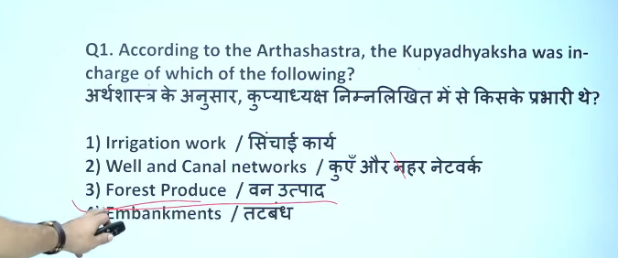

Q.2
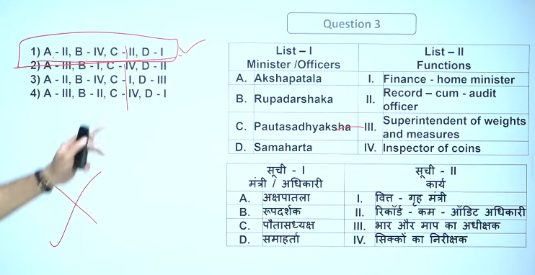

Q.3
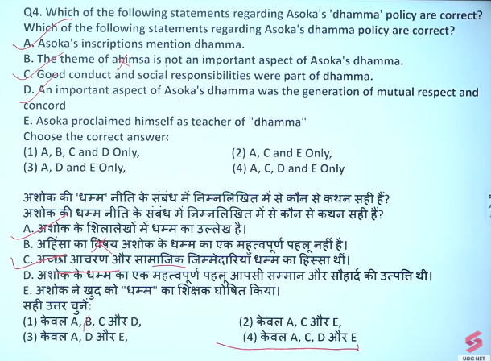
- Ashoka’s moral policy – Ashoka Dhamma was a code of ethical conduct, not a religion.
- Ahimsa (Non-violence) – It emphasized non-killing of humans and animals.
- Religious tolerance – Respect for all religions and sects.
- Social responsibility – Kindness towards parents, elders, servants, and slaves.
- Public welfare – Promotion of hospitals, wells, roads, and trees for people and animals.
- Moral behavior – Encouraged truthfulness, self-control, and compassion.
- No forced conversions – Focused on persuasion, not coercion.
- Spread through inscriptions – Ashoka spread Dhamma via rock and pillar edicts.
📌 One-line for exams:
Ashoka Dhamma was a set of moral and social principles aimed at promoting peace, tolerance, and welfare.

Does “Dhamma” mean “Dharma”?
Short answer: 👉 Yes, but not exactly the same meaning.

In Ashoka’s context:
- Dhamma ≠ Religion
- It means moral law / ethical conduct / right way of living

Simple Hindi:
👉 Ashoka ka Dhamma = achha acharan (good behavior)
👉 Ye kisi ek dharm (religion) ka naam nahi tha

Difference in easy words:
Dharma | Dhamma (Ashoka)
Religious duty | Moral duty
Rituals, beliefs | Ethics, values
Spiritual focus | Social harmony
Ashoka’s Dhamma referred to ethical and moral principles, not religious Dharma.

es, the theme of Ahimsa (non-violence) is a core component and a central pillar of Emperor Ashoka’s Dhamma. Following the Kalinga War, Ashoka promoted compassion, non-injury to animals, and peaceful coexistence over military conquest, embedding these principles into his ethical framework for a harmonious society.
Key Aspects of Ahimsa within Ashoka's Dhamma:
- Prohibition of Animal Sacrifice: Ashoka's Major Rock Edict I banned the slaughter of animals for food and religious sacrifices, promoting their sanctity.
- Compassionate Conduct: Dhamma mandated humane treatment of servants and slaves, as well as respect for elders, relatives, and religious practitioners.
- Broader Social Harmony: Non-violence was part of a broader, non-sectarian moral code (Dhamma) meant to promote peace in a diverse empire, not just the promotion of Buddhism.
- Active Compassion: Beyond abstinence from violence, it encouraged active care for all living beings

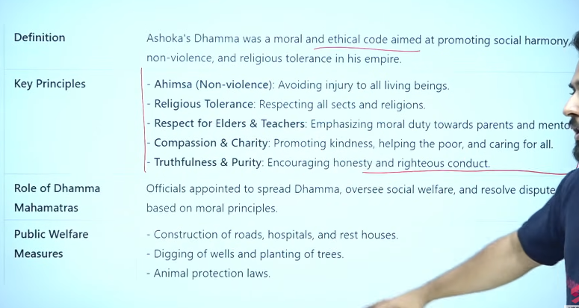
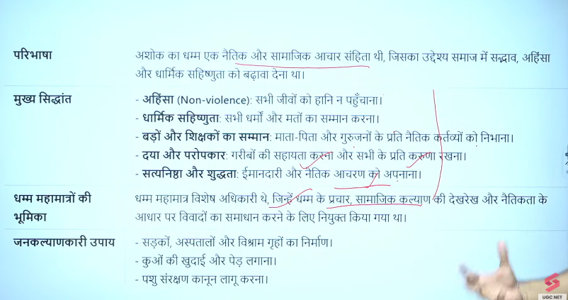

Q.4
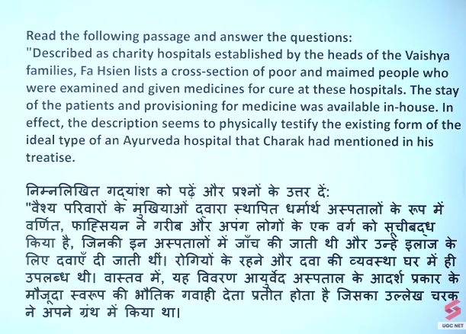
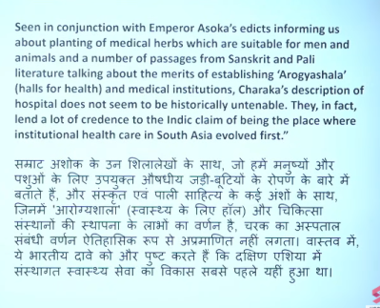

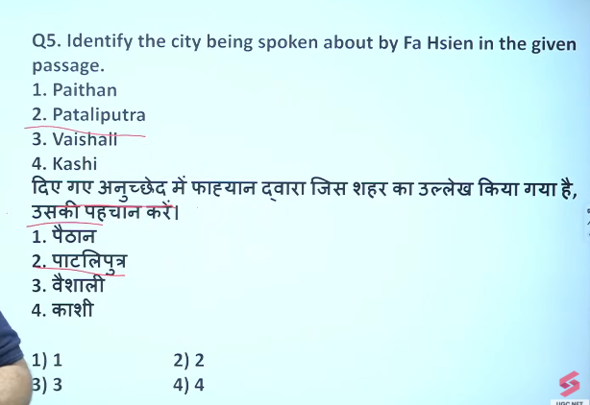

Ans: patliputra
Faihan Chandragupta 2 ke bare me batata hai
Q.5
Ans:1
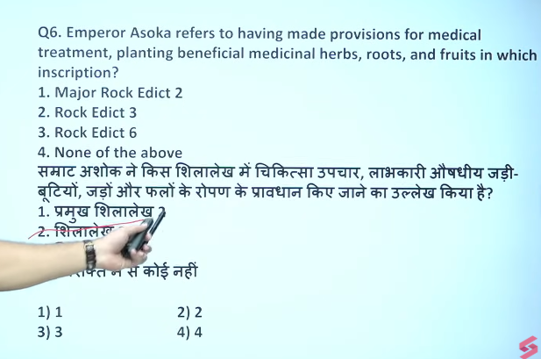

Ans: 1 major rock edict 2
अशोक के धम्म का प्रचार करने के लिए अधिकारियों (युक्त, प्रादेशिक और राजुक) द्वारा हर 5 साल में निरीक्षण करने (धम्म यात्रा) का उल्लेख तीसरे मुख्य शिलालेख (Major Rock Edict III) में किया गया है।

Q.6 Big three of aurveda is Charak, Shrushrrut, vagbhatt

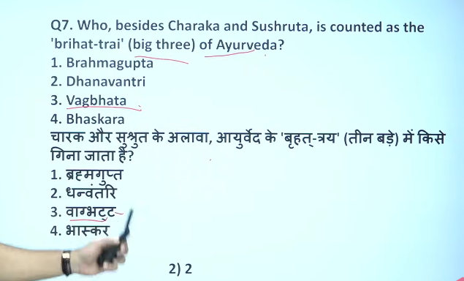
Vagbhata (c. 6th–8th century AD) was a pivotal Ayurvedic scholar who consolidated the "Great Three" (Brhatrayi) of Ayurveda by compiling the Aṣṭāṅgahṛdaya and Aṣṭāṅgasaṅgraha.
Vagbhata (c. 6th–8th century) was a foundational Ayurvedic scholar who completed the "Great Three" (Brhatrayi) of Indian medicine. His major contributions,
Vagbhata (c. 6th–8th century AD) was a highly influential, classical Ayurvedic physician, surgeon, and scholar in ancient India, recognized as one of the "Great Three" (Brhat-trayi) of Ayurveda alongside Charaka and Sushruta. He is best known for composing the Ashtanga Sangraha and Ashtanga Hridaya Samhita, which synthesized earlier medical knowledge.

Brahmagupta (598–668 CE) was a pivotal ancient Indian mathematician and astronomer
Dhanvantri is primarily known as the "God of Medicine" and the founder of Ayurveda
Dhanvantari is the Hindu god of Ayurveda and Medicine, revered as an avatar of Lord Vishnu and the physician of the gods. He emerged from the Samudra Manthan (Churning of the Ocean) holding a pot of Amrita (nectar of immortality). Known as the father of Ayurveda, he is worshipped for health, longevity, and healing, particularly on Dhanteras.

Bhāskara II (1114–1185 AD), or Bhāskarāchārya, was a 12th-century Indian mathematician and astronomer who made pioneering advancements in algebra, arithmetic, and calculus. He authored Siddhānta Shiromani, featuring Līlāvatī and Bījagaṇita, introducing concepts like differential calculus, negative/irrational numbers, and the general solution to the Pell equation, often centuries before European mathematicians.
Lilavati is a foundational 12th-century Sanskrit treatise on mathematics and astronomy written by Indian mathematician Bhaskara II (Bhaskaracharya) in 1150 A.D.. As the first part of his magnum opus, Siddhanta Shiromani, it covers arithmetic, algebra, geometry, and mensuration through poetic verses. It is renowned for its practical problems, including permutations, progressions, and indeterminate equations, which remained standard, influential text for centuries.

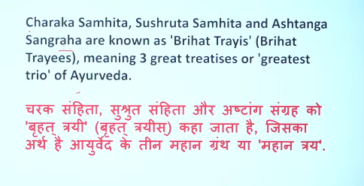
“Besides” का हिन्दी में मतलब context के हिसाब से बदलता है 👇
1. Besides = के अलावा / के अतिरिक्त
👉 Example:
- Besides Ram, Shyam also came
➡️ राम के अलावा श्याम भी आया

2. Besides = इसके अलावा (moreover)
👉 Example:
- It is cheap, besides it is good
➡️ यह सस्ता है, इसके अलावा यह अच्छा भी है

3. Besides = के पास / बगल में (less common)
👉 Example:
- He sat beside me (यह “beside” है, besides नहीं)
➡️ वह मेरे पास बैठा

One-line 👇
👉 Besides = के अलावा / इसके अतिरिक्त 👍

Q.7

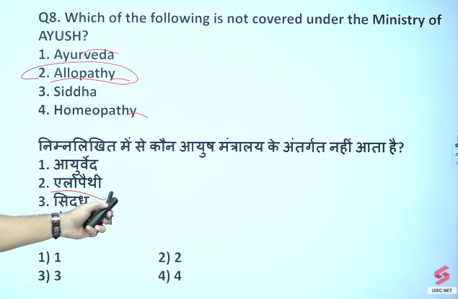

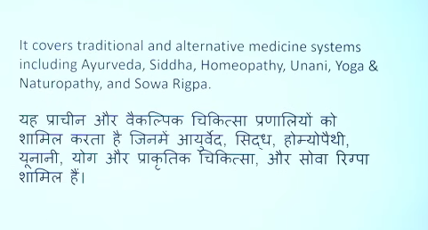

Q.8

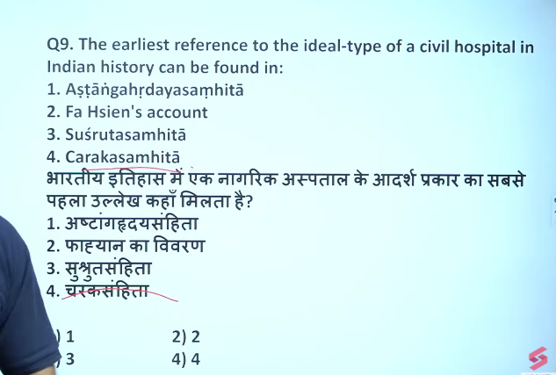

This is passage question answer is 4

Q.10 ans:c
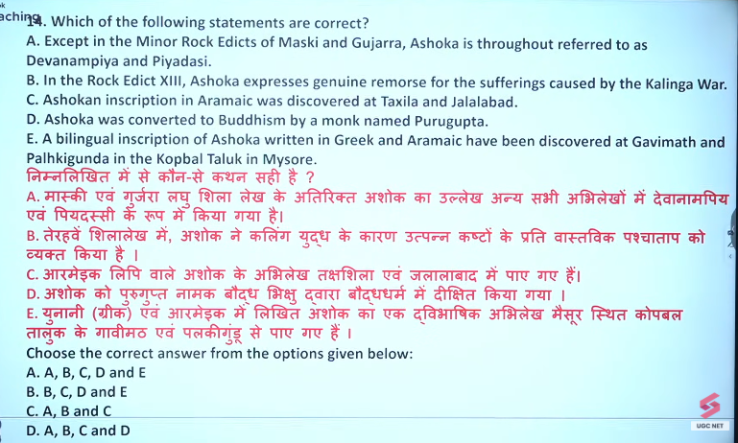

A famous bilingual inscription of the Mauryan Emperor Ashoka, written in Greek and Aramaic, was discovered at Kandahar in Afghanistan.
Key details regarding this discovery include:
- Place: The inscription was found at Chehel Zina (or Chil Zina), a mountainous outcrop near Old Kandahar, Afghanistan.
- Discovery Year: The bilingual rock inscription (also known as the Kandahar Edict of Ashoka) was discovered in 1958.
- Content: The inscription is a bilingual text where the Greek version (top) and Aramaic version (bottom) advocate the adoption of piety ("Eusebeia" in Greek, "Qsyt" in Aramaic) to the local Greek and Iranian communities.
- Significance: It is among the earliest-known edicts of Ashoka, dating back to around 260 BCE (the 10th year of his reign).
Other Ashokan Inscriptions in the Region:
- Kandahar Greek Inscription (1963): Another inscription in the same area was found written only in Greek.
- Laghman Aramaic Inscription: Aramaic inscriptions (not bilingual with Greek) have also been found in the Laghman Valley.
- Taxila Aramaic Inscription: An Aramaic inscription was discovered at Taxila, Pakistan.

Major Rock Edict 13 of Ashoka is the most crucial, largest, and longest inscription detailing his victory over Kalinga (c. 261 BC), expressing profound remorse for the immense suffering caused. It marks his transformation to Buddhism, shifting policy from territorial conquest to Dhamma (righteousness).
- Impact of Kalinga War: Ashoka expresses deep guilt for the death, abduction, and slaughter of hundreds of thousands during the Kalinga war.
- Transformation: It signifies his ideological shift from Digvijaya (conquest of regions) to Dhammavijaya (conquest by piety).
- Key Contents:
  - External Relations: Lists contemporary Greek kings, including Antiochus (Syria), Ptolemy (Egypt), Magas (Cyrene), Antigonus (Macedon), and Alexander (Epirus), indicating diplomatic connections.
  - Internal Relations: Mentions interactions with tribes and nations within his empire.
  - Proclamation of Peace: Declares that true conquest is that of hearts through Dhamma.
- Significance: It serves as a historical turning point in the Mauryan Empire, setting a new moral standard for governance.
The edict has been found at sites like Dhauli in Odisha and Khalsi
Ashoka accepted and proclaimed his policy of Dhamma (righteousness) primarily following the Kalinga War, with this shift in ideology detailed in Major Rock Edict XIII. This edict describes his remorse over the war and the replacement of physical conquest (
) with cultural conquest through Dhamma (
).
Key details regarding this shift:
- Major Rock Edict XIII: Mentions the devastation of the Kalinga war and acts as the official turning point where Ashoka pledges to follow and spread the Dhamma.
- Major Rock Edict XI: Elaborates on the content of Dhamma, defining its principles such as respect for elders, kindness to servants, and non-violence.
- Context: The conversion occurred after the Kalinga war, which took place eight years after his coronation.
Major Rock Edict II | Medical treatment of humans and animals, planting of fruits, medicinal herbs and the digging of wells. Mentions the Pandyas, Satyapuras and Keralaputras of South India.

It is the largest inscription from the edict. It talks about the Ashoka's (r.268 - 232 BC) victory over Kalinga (262 - 261 BC) and mentions his remorse for the half million killed or deported during his conquest, by "Dhamma".^{[10]} The edict asserts that in no land, except those of the Greeks, do not orders of Brahmans and Śramaṇa now exist to instruct on "Dhamma"; the forest tribes should repent or be killed; and he has conquered the lands, for 600 Yojana, to the borders of several named Greek rulers:
- Amtiyoga or Amtiyaka (𑀅𑀁𑀢𑀺𑀬𑀓), identified with Antiochus II Theos (r.261 - 246 BC) of the Seleucid Empire^{[11]}
- Tulamaya (𑀢𑀼𑀭𑀫𑀸𑀬), identified with Ptolemy III Euergetes of Egypt (r.246 - 222 BC)^{[12]}
- Antekina (𑀅𑀁𑀢𑁂𑀓𑀺𑀦), identified with Antigonus Gonatus of Macedonia (r.277 - 239 BC)^{[12]}
- Maka, identified with Magas of Cyrene (r.276 – 250 BC)^{[12]}
- Alikyashudala, possibly identified with Alexander II of Epirus (r.272 - 255 BC)^{[12]}
It also mentions the victory of Dhamma in south India among the Cholas and Pandyas, as far as Ceylon.
This edict was also written in Greek (probably together with all the other Major Rock Edicts I-XIV originally) in the Kandahar Greek Edict of Ashoka (first portion recovered).
Here are 10 very short points (one-liners):
- Ashoka conquered Kalinga
- Massive loss of life and deportation
- Ashoka felt deep remorse
- Rejected further wars
- Adopted Dhamma policy
- Promoted non-violence
- Emphasized moral governance
- Mentioned suffering of all people
- Dhamma spread to foreign (Greek) rulers
- Reached South India and Sri Lanka
👉 Core idea: War → regret → Dhamma 👍

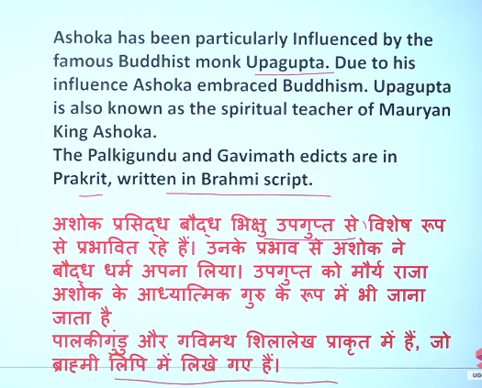

Ashoka respects and advises proper treatment of Brahmins and Shramanas (ascetics) primarily in his Major Rock Edict III, where he mentions that liberality and respect towards them are virtues. This respect is also highlighted in Major Rock Edict IV, which advocates for courtesy to them, along with other religious groups.
Key points regarding this respect:
- Major Rock Edict III: Specifically mentions that "generosity towards Brahmins and Shramanas" is a component of righteous living.
- Major Rock Edict IV: Mentions that non-violence and respect towards Shramanas and Brahmins have been increased under his rule.
- Theme: The overarching theme of his edicts (e.g., Major Rock Edict VII & XII) emphasizes tolerance and honouring all sects, rather than just one's own.
These measures were part of his policy of Dhamma (righteousness) designed to promote social harmony and moral conduct.

Q.11
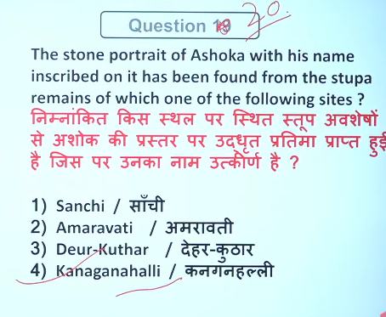
The only known stone portrait of Emperor Ashoka with his name inscribed was found at Kanaganahalli, near Sannati in the Kalaburagi district of Karnataka, India. Excavated by the Archaeological Survey of India (ASI) between 1994 and 2001, the relief sculpture on a limestone slab features a Brahmi inscription that reads "Ranyo Ashoka" (King Ashoka).

14
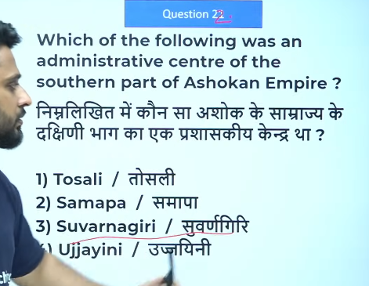
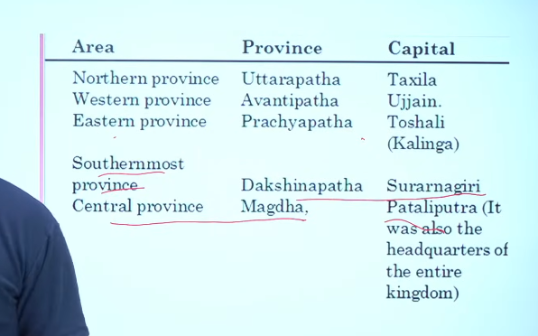

15
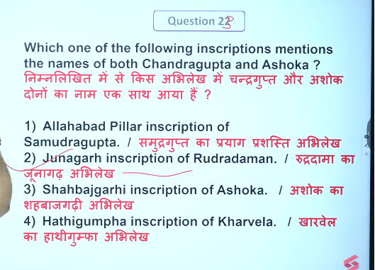

17
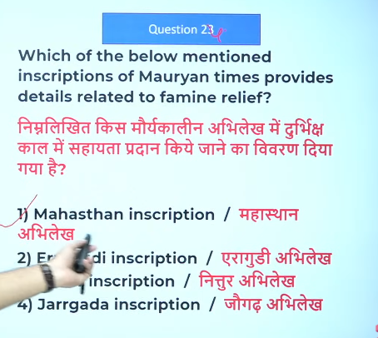

18
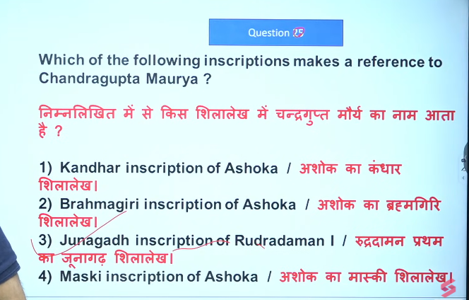
👉 Reference = उल्लेख (mention करना)
👉 “Which inscription makes a reference to Maurya?”
➡️ कौन सा शिलालेख (inscription) Maurya का ज़िक्र करता है?
👉 Reference = किसी चीज़ का ज़िक्र / उल्लेख करना

Different simple meanings:
- Mention (ज़िक्र करना)
👉 He made a reference to history
➡️ उसने इतिहास का ज़िक्र किया
2. Source / Example (संदर्भ)
👉 I used this book as a reference for my project
➡️ मैंने इस किताब को अपने प्रोजेक्ट के लिए संदर्भ के रूप में इस्तेमाल किया

3. Connection (संबंध दिखाना)
👉 This story makes a reference to ancient history
➡️ यह कहानी प्राचीन इतिहास से संबंध दिखाती है

One-line समझो 👇
- Reference (source) = जहाँ से जानकारी लेते हैं
- Reference (connection) = किसी चीज़ को दूसरी से जोड़ना 👍

👉 Reference = किसी चीज़ को बताने, जोड़ने या उदाहरण के रूप में इस्तेमाल करना 👍
Difference समझो आसान तरीके से 👇
1. Reference (noun)
👉 मतलब: ज़िक्र / उल्लेख
- This is a reference to Maurya
➡️ यह मौर्य का ज़िक्र है

2. Make a reference (verb phrase)
👉 मतलब: ज़िक्र करना (action)
- This inscription makes a reference to Maurya
➡️ यह शिलालेख मौर्य का ज़िक्र करता है

क्यों “make” लगाया जाता है?
👉 English में action दिखाने के लिए
- Reference = चीज़ (noun)
- Make a reference = काम (verb/action)

Simple trick 👇
👉 Reference = क्या? (thing)
👉 Make a reference = क्या कर रहा है? (action)

One-line 👇
👉 “make” इसलिए आता है क्योंकि वह action (ज़िक्र करना) दिखाता है 👍

19 9-

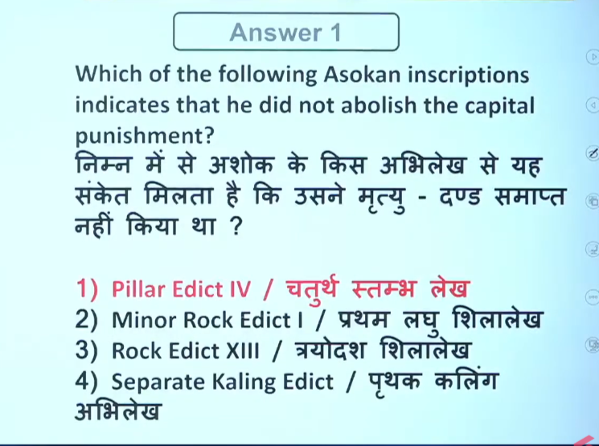

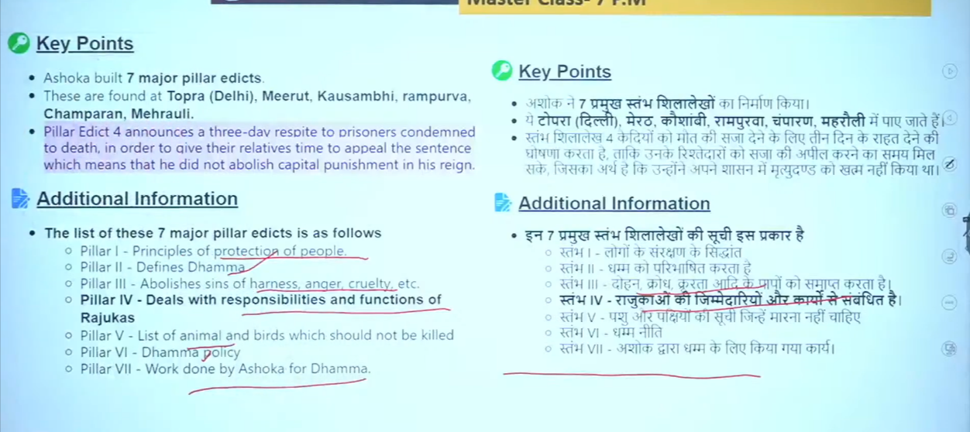

Q.20
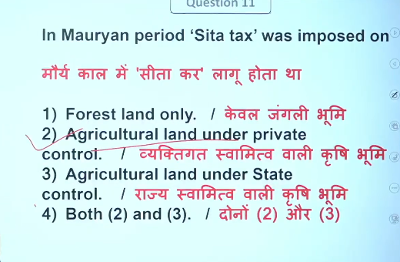

Q.21
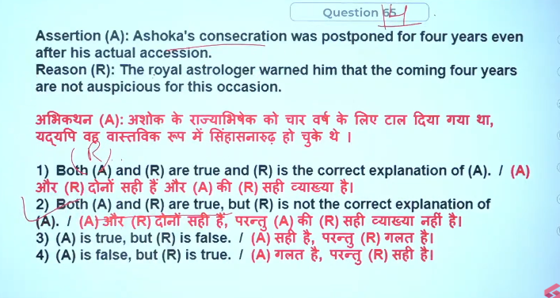

22
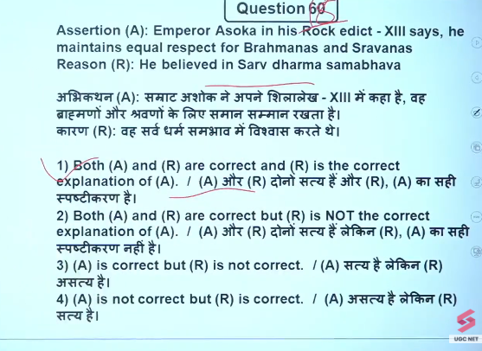
Ashoka believed in Sarva Dharma Sambhava (equal respect for all religions/sects) and promoted religious tolerance in his Major Rock Edict XII. In this edict, he calls for a "gathering of all sects" and emphasizes that by honoring other sects, one brings glory to their own and acts in the service of everyone.
- Key Focus of Edict XII: Advocates for harmony, mutual respect, and the restriction of over-praising one's own faith while condemning others.
- Other Contexts: While Edict XII focuses on general tolerance, the Bhabru Minor Rock Edict reveals his personal devotion to Buddhism.

The statement that Ashoka maintained equal respect for Brahmins and Sramanas (Sarvanas) is primarily found in Major Rock Edict XII, not Edict XIII, which focuses on the Kalinga war and regret. Major Rock Edict XII emphasizes religious tolerance, promoting respect for all sects (Pasandas) and advocating for harmony and restraint in speech regarding other faiths.
अशोक द्वारा ब्राह्मणों और श्रमणों (सर्वन) के प्रति समान सम्मान रखने का उल्लेख मुख्य रूप से मेजर रॉक एडिक्ट XII में मिलता है, न कि एडिक्ट XIII में। एडिक्ट XIII मुख्यतः कलिंग युद्ध और उसके प्रति अशोक के पश्चाताप पर केंद्रित है।
मेजर रॉक एडिक्ट XII में धार्मिक सहिष्णुता पर विशेष जोर दिया गया है। इसमें सभी संप्रदायों (पसंदों) के प्रति सम्मान रखने, आपसी सद्भाव बनाए रखने और अन्य धर्मों के बारे में संयमित वाणी का प्रयोग करने की शिक्षा दी गई है।

Ashoka's Rock Edict XII is a profound call for religious tolerance, harmony, and respect among all sects. It emphasizes that by honoring other faiths, one promotes their own, while disparaging others hurts one's own faith. Ashoka advocated for "restraint of speech" and dialogue, encouraging that only the "essential growth" of all religions should be honored.
Testbook +2
Key aspects of Rock Edict XII:
- Religious Tolerance: It encourages a "growth of essence" in all religions, fostering mutual respect.
- Non-disparagement: It strongly opposes praising one's own religion while criticizing another's.
- Dialogue:
Ashoka advocates that followers of all sects should be "well-learned" and discuss faith, leading to spiritual growth.
- Welfare Focus: The core aim is to promote the welfare of all people, rather than just the victory of a single perspective.
Testbook +4
This edict is part of the 14 Major Rock Edicts and highlights Ashoka's commitment to creating a harmonious society under the principles of Dhamma.
अशोक का मेजर रॉक एडिक्ट XII – संक्षिप्त हिंदी सार 👇
अशोक का मेजर रॉक एडिक्ट XII धार्मिक सहिष्णुता और विभिन्न संप्रदायों के बीच सामंजस्य को बढ़ावा देने पर आधारित है। इसमें उन्होंने एक ऐसे समाज की कल्पना की है जहाँ सभी धर्म शांति से साथ रह सकें।
मुख्य बिंदु:
- सहिष्णुता का संदेश: सभी धर्मों (वैदिक/हिंदू, बौद्ध, जैन आदि) के प्रति सम्मान रखने की बात कही गई है।
- वाणी पर संयम: अपने धर्म की प्रशंसा करते हुए दूसरों की निंदा नहीं करनी चाहिए।
- धर्म का सार (Essence): उपहार या सम्मान से अधिक महत्वपूर्ण सभी धर्मों के मूल तत्वों का विकास है।
- अन्य धर्मों का सम्मान: दूसरों के धर्म का सम्मान करने से अपना धर्म भी मजबूत होता है।
- धम्म महामात्रों की भूमिका: विशेष अधिकारी (धम्म महामात्र) धार्मिक सहिष्णुता और धर्म के मूल सिद्धांतों के प्रचार के लिए नियुक्त थे।
- आपसी ज्ञान-विनिमय: सभी संप्रदायों को एक-दूसरे के अच्छे विचारों को समझने और सीखने के लिए प्रोत्साहित किया गया।
👉 निष्कर्ष:
यह अभिलेख अशोक की धार्मिक उदारता और समानता की नीति को दर्शाता है, जो एक शांतिपूर्ण और बहुलतावादी समाज के निर्माण पर आधारित थी।
give this in english too
Ashoka’s Major Rock Edict XII – Short English Summary 👇
Ashoka’s Major Rock Edict XII focuses on religious tolerance and harmony among different sects. It reflects his vision of a society where all religions can coexist peacefully.
Key Points:
- Appeal for Tolerance: Respect should be shown to all religious sects (Vedic/Hindu, Buddhist, Jain, etc.).
- Restraint in Speech: One should not praise their own religion while criticizing others.
- Essence of Religion: Ashoka valued the growth of the core principles of all religions more than gifts or honors.
- Respect for Other Faiths: Honoring other religions helps strengthen one’s own faith.
- Role of Dhamma Mahamatras: Special officers were appointed to promote moral values and religious harmony.
- Inter-sect Dialogue: People were encouraged to learn and understand the good teachings of other religions.
👉 Conclusion:
This edict highlights Ashoka’s policy of religious tolerance, equality, and peaceful coexistence in society.

XII = 12 (बारह)
4 – IV → 4
5 – V → 5
6 – VI → 6
7 – VII → 7
8 – VIII → 8
9 – IX → 9
10 – X → 10
11 – XI → 11
12 – XII → 12
13 – XIII → 13
14 – XIV → 14
15 – XV → 15
19 in Roman numerals = XIX
👉 Breakdown:
- X = 10
- IX = 9
So, 10 + 9 = 19

Rock Edict 13 of Ashoka is the largest and most significant inscription, detailing his profound remorse for the violent conquest of Kalinga (c. 262–261 BC). It marks Ashoka’s transformation, announcing his conversion to Buddhism, abandonment of war for "Dhamma Vijaya" (conquest by piety), and mentions Hellenistic kings.
Key Aspects of Rock Edict 13:
- Kalinga War Remorse: It vividly describes the immense suffering caused by the Kalinga war, including the deaths and deportation of hundreds of thousands of people, which caused intense guilt and repentance for King Priyadarshi (Ashoka).
- Shift in Policy:
The edict announces that "conquest by Dhamma" (moral force) is now considered the true conquest, replacing the traditional conquest by force.
- Foreign Relations: The inscription lists contemporary Greek/Hellenistic kings to whom Ashoka sent missions of Dhamma, including:
  - Amtiyoko (Antiochus II of Syria)
  - Turamaye (Ptolemy II of Egypt)
  - Maka (Magas of Cyrene)
  - Amtikini (Antigonus II Gonatas of Macedon)
  - Alikasudaro (Alexander II of Epirus)
- Impact on Society: It highlights the spread ofDhamma within the Mauryan Empire and to neighboring lands, including South India and Sri Lanka.
- Warning to Tribes: It warns forest tribes, who were part of the empire, that despite his repentance, the king still holds power and they should repent to avoid punishment.
The 13th Major Rock Edict, located in sites like Dhauli, Jaugada, and Kalsi, acts as a crucial historical document confirming the transformation of Ashoka
अशोक का मेजर रॉक एडिक्ट XII – संक्षिप्त हिंदी सार 👇
अशोक का मेजर रॉक एडिक्ट XII धार्मिक सहिष्णुता और विभिन्न संप्रदायों के बीच सामंजस्य को बढ़ावा देने पर आधारित है। इसमें उन्होंने एक ऐसे समाज की कल्पना की है जहाँ सभी धर्म शांति से साथ रह सकें।
मुख्य बिंदु:
- सहिष्णुता का संदेश: सभी धर्मों (वैदिक/हिंदू, बौद्ध, जैन आदि) के प्रति सम्मान रखने की बात कही गई है।
- वाणी पर संयम: अपने धर्म की प्रशंसा करते हुए दूसरों की निंदा नहीं करनी चाहिए।
- धर्म का सार (Essence): उपहार या सम्मान से अधिक महत्वपूर्ण सभी धर्मों के मूल तत्वों का विकास है।
- अन्य धर्मों का सम्मान: दूसरों के धर्म का सम्मान करने से अपना धर्म भी मजबूत होता है।
- धम्म महामात्रों की भूमिका: विशेष अधिकारी (धम्म महामात्र) धार्मिक सहिष्णुता और धर्म के मूल सिद्धांतों के प्रचार के लिए नियुक्त थे।
- आपसी ज्ञान-विनिमय: सभी संप्रदायों को एक-दूसरे के अच्छे विचारों को समझने और सीखने के लिए प्रोत्साहित किया गया।
👉 निष्कर्ष:
यह अभिलेख अशोक की धार्मिक उदारता और समानता की नीति को दर्शाता है, जो एक शांतिपूर्ण और बहुलतावादी समाज के निर्माण पर आधारित थी।
give this in english too
Ashoka’s Major Rock Edict XII – Short English Summary 👇
Ashoka’s Major Rock Edict XII focuses on religious tolerance and harmony among different sects. It reflects his vision of a society where all religions can coexist peacefully.
Key Points:
- Appeal for Tolerance: Respect should be shown to all religious sects (Vedic/Hindu, Buddhist, Jain, etc.).
- Restraint in Speech: One should not praise their own religion while criticizing others.
- Essence of Religion: Ashoka valued the growth of the core principles of all religions more than gifts or honors.
- Respect for Other Faiths: Honoring other religions helps strengthen one’s own faith.
- Role of Dhamma Mahamatras: Special officers were appointed to promote moral values and religious harmony.
- Inter-sect Dialogue: People were encouraged to learn and understand the good teachings of other religions.
👉 Conclusion:
This edict highlights Ashoka’s policy of religious tolerance, equality, and peaceful coexistence in society.
give me point wise ashoka given inforation in rock edict 12
Point-wise information given by Ashoka in Major Rock Edict XII 👇
- Religious Tolerance: All sects (Pasandas) should be respected equally.
- No Blind Praise: One should not excessively praise their own religion.
- No Criticism of Others: Avoid criticizing or condemning other religions.
- Restraint in Speech: Control over speech is essential to maintain harmony.
- Respect for Other Faiths: Honoring other sects helps in the growth of one’s own religion.
- Essence over Rituals: Importance is given to the core values (essence) of religions rather than rituals, gifts, or honors.
- Promotion of Harmony: Aim is to create peaceful coexistence among different religious groups.
- Dhamma Mahamatras: Special officers were appointed to spread Dhamma and ensure tolerance.
- Inter-sect Learning: People should learn good teachings from other religions.
👉 In short:
Ashoka emphasized tolerance, mutual respect, and unity among religions in Rock Edict XII.
ashokag give informaiton in rock edict 13
Ashoka – Information given in Major Rock Edict XIII (Point-wise) 👇
- Kalinga War: Describes the conquest of Kalinga War by Ashoka.
- Mass Suffering: Mentions large-scale loss of life, deportation, and suffering of people.
- Ashoka’s Regret: Expresses deep remorse (dukkha) after seeing the destruction caused by war.
- Moral Transformation: This war led to Ashoka’s change of heart and adoption of Dhamma (moral policy).
- Rejection of Violence: Ashoka declares that he now prefers Dhamma-vijaya (conquest by righteousness) over military conquest.
- Spread of Dhamma: Emphasizes spreading moral values like compassion, kindness, and non-violence.
- Concern for All People: Shows care not only for his own subjects but also for people in neighboring regions.
- Foreign Rulers Mentioned: Refers to Greek (Yavana) kings like Antiochus II Theos and others, indicating diplomatic relations.
- Universal Message: Promotes peace, tolerance, and welfare of all humanity.
👉 In short:
Rock Edict XIII highlights Ashoka’s regret after the Kalinga War and his shift from war to peace (Dhamma-vijaya).

23
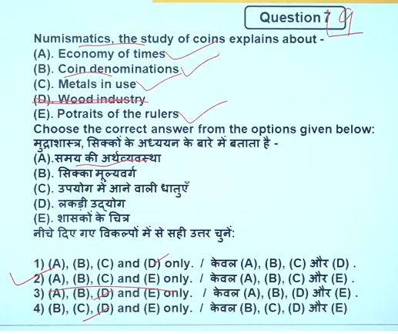
24
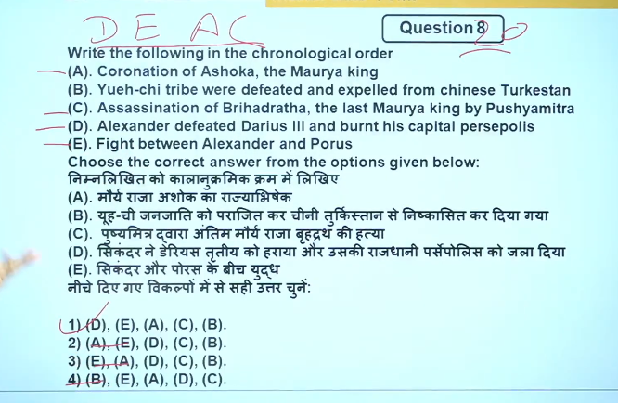
326B
Alexander the Great defeated Darius III of Persia in two major, decisive battles: Issus (333 BC) and Gaugamela (331 BC).
Emperor Ashoka was formally coronated around 269–268 BCE, four years after ascending the throne in 273 BCE. Following a turbulent succession, he reigned until 232 BCE, marking the zenith of the Mauryan Empire. His reign shifted from territorial expansion to "Dhamma-conquest" (righteous rule) after the 261 BCE Kalinga War.
Key Details of Ashoka's Coronation:
- Date: Approximately 269–268 BCE. While he became king in 273 BCE, his coronation was delayed, possibly due to a war of succession.
- Significance: It solidified his position as the third Mauryan emperor after Chandragupta and Bindusara
- Reign Duration: 273–232 BCE.
- Title: He took the title Devanampriya Priyadarsi ("Beloved-of-the-Gods, He who gazes on with affection").
- Post-Coronation Shift: Eight years after his coronation (c. 261 BCE), the brutal Kalinga War caused him to renounce violence and adopt Buddhism.
- Legacy: He transformed the empire into a welfare state, promoting religious tolerance and ethical governance, or "Dhamma".
Following the coronation, Ashoka's reign was characterized by the establishment of, at least, 14 major rock edicts. These, along with other inscriptions, demonstrate a shift from military conquest to a policy of non-violence and moral victory Britannica.

25
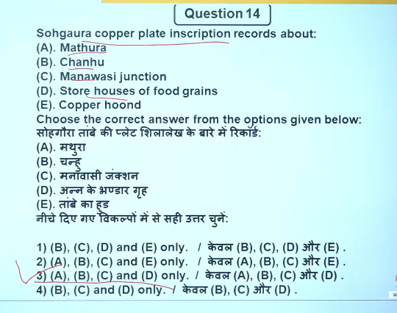
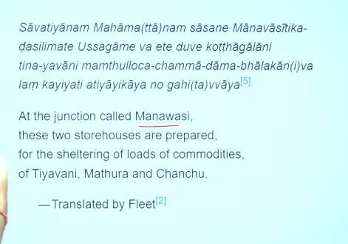

The Sohgaura copper plate inscription is the oldest known Indian copper plate inscription, dating back to the Mauryan period (3rd-2nd century BCE), discovered near the Rapti River in Uttar Pradesh. It is a 4-line Prakrit/Brahmi text documenting famine relief measures and the establishment of grain depots (Kosthagara) to combat starvation.
Key Details of the Inscription:
- Purpose: It records royal orders for storing grain and providing relief, highlighting ancient Indian administrative care, particularly during droughts.
- Location: Discovered in Sohgaura, Gorakhpur district, Uttar Pradesh.
- Content:
The text mandates the construction of two granaries (kosthagara) at specific locations (likely near Mathura/Manawasi junction) for public use during times of scarcity.
- Script and Language: Written in Prakrit language and Brahmi script.
- Symbols: The plate features pictorial symbols—a tree in a railing, a mountain (crescent-on-hill), and granary structures—often interpreted as royal insignia designed for understanding by the general population.
- Significance: It is often regarded as a testament to the efficient administrative machinery and Rajadharma (duty of the king) regarding public welfare.
Scholars generally place the inscription in the early Mauryan period (3rd Century BCE), with some debate on whether it belongs to the reign of Chandragupta Maurya or his grandson Ashoka.
सोहगौरा ताम्रपत्र अभिलेख (Sohgaura Copper Plate Inscription) – हिंदी में सार 👇
- यह एक प्राचीन भारतीय अभिलेख है, जिसे आमतौर पर 3री शताब्दी ईसा पूर्व (मौर्य या पूर्व-मौर्य काल) का माना जाता है।
- इसका मुख्य विषय अकाल राहत (Famine Relief) और राज्य के संसाधनों का प्रबंधन है।

🔑 मुख्य बातें (Key Points):
- भंडारगृह की स्थापना (कोष्ठागार):
  - राजा द्वारा अनाज के भंडार (granaries) बनाने और उन्हें बनाए रखने का आदेश दिया गया।
  - इनका उपयोग अकाल या सूखे के समय जनता को भोजन देने के लिए किया जाता था।
- भौगोलिक स्थानों का उल्लेख:
  - अभिलेख में कुछ स्थानों का उल्लेख मिलता है, जैसे:
    - मथुरा
    - चंचु (Chanhu/Chanhuan)
    - मानवासी / मानवासीतिक (camp/junction)
- अनाज भंडारण:
  - इसमें बताया गया है कि दो भंडारगृहों में अनाज जमा किया जाता था ताकि संकट के समय उपयोग हो सके।
- अकाल के समय वितरण:
  - आदेश दिया गया कि संकट के समय अनाज को रोका न जाए, बल्कि जनता में वितरित किया जाए।
- राजधर्म का प्रमाण:
  - यह अभिलेख दर्शाता है कि राजा का कर्तव्य (राजधर्म) था कि वह जनता के कल्याण के लिए संसाधनों का सही प्रबंधन करे।
- स्थान:
  - यह अभिलेख सोहगौरा (जिला गोरखपुर, उत्तर प्रदेश) से प्राप्त हुआ है।

👉 निष्कर्ष:
यह अभिलेख अकाल राहत, खाद्य सुरक्षा और जनकल्याण के लिए राज्य की सक्रिय भूमिका को दर्शाता है।

26
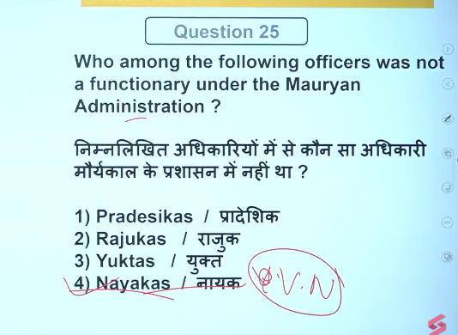
🌾 1. Rajuk (राजुक)
- English: Rural officer / District magistrate-type
- Hindi: ग्रामीण प्रशासन अधिकारी
👉 Role:
- Looked after land measurement and revenue collection
- Performed judicial functions (gave justice in local disputes)
- Maintained law and order in rural areas

📋 2. Yukta (युक्त)
- English: Subordinate official / Executive officer
- Hindi: अधीनस्थ अधिकारी
👉 Role:
- Assisted higher अधिकारियों like Mahamatras and Pradeshikas
- Maintained records and accounts
- Implemented government orders at ground level
- छोटा/मिड-लेवल सरकारी कर्मचारी (assistant type)
- ऊपर के अधिकारियों के आदेश लागू करना
- रिकॉर्ड और हिसाब-किताब रखना
- रोज़मर्रा का प्रशासन चलाना
- काम करने वाला कर्मचारी (executor)

🏛️ 3. Pradeshika (प्रादेशिक)
- English: Provincial governor / Inspector
- Hindi: प्रांत अधिकारी
👉 Role:
- Supervised district administration
- Collected revenue and ensured law & order
- Conducted inspections and tours to check officials
- Reported directly to the king
- बड़े स्तर का अधिकारी (district/province का boss)
👉 काम क्या करता था?
- पूरे इलाके की देख-रेख (supervision)
- राजस्व (tax) वसूली पर निगरानी
- कानून-व्यवस्था maintain करना
- दूसरे अधिकारियों (जैसे Yukta, Rajuk) को check करना
👉 Simple line:
➡️ Pradeshika = supervisor / inspector (बॉस type)

🔥 Final Trick (याद रखने के लिए):
- Yukta → Worker (काम करने वाला)
- Pradeshika → Boss (देख-रेख करने वाला)

👉 In short:
- Rajuk → Justice + land & rural administration
- Yukta → Assistant / record-keeping officer
- Pradeshika → Supervisor of provinces & districts
✔️ These officials ensured efficient governance in Mauryan Empire 👍

===========================================================================

🏛️ Central Administration Officials
- Mantri (Minister): Chief acdvisor to the king
- Purohita: Religious advisor and guide
- Senapati: Head of the army
- Yuvaraja: Crown prince, sometimes involved in administration
- Amatyas: High-ranking officials/administrators

📜 Important Departments & Officers
- Samaharta: Chief revenue collector (tax department head)
- Sannidhata: Treasurer (in charge of state treasury)
- Akshapataladhyaksha: Accountant General (keeps financial records)
- Panyadhyaksha: Superintendent of trade and commerce
- Akaradhyaksha: Head of mines
- Sitadhyaksha: In charge of agriculture

⚖️ Law & Order Officials
- Dandapala: Chief of police / law enforcement
- Antapala: Frontier officer (border security)
- Nagaradhyaksha: City administrator

🌍 Provincial Administration
- Kumara / Aryaputra: Provincial governor (usually royal family member)
- Mahamatras: High officials for administration and welfare

☸️ Special Officials under Ashoka
- Dhamma Mahamatras: Spread and supervise Dhamma (moral law)
- Rajukas: Officers for land measurement and justice
- Yuktas: Subordinate officials assisting administration

👉 In short:
Mauryan administration was highly organized and centralized, with different officers handling revenue, army, justice, and welfare.

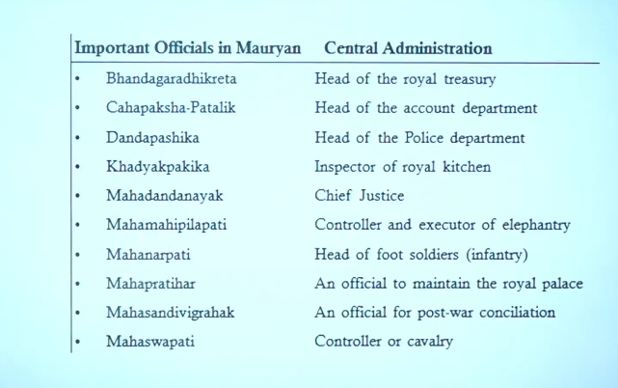

The Mauryan administration was a highly centralized bureaucracy managed by a strict hierarchy of officers, with the king at the center assisted by the Mantri Parishad (Council of Ministers). Key officials included the Samaharta (revenue collector), Sannidhata (treasurer), Senapati (commander-in-chief), and Pradeshika (provincial/district administrators).
Key Central Officers
- Mantri: Minister
- Purohita: Chief Priest
- Yuvaraja: Crown Prince
- Senapati: Commander-in-chief of the armed forces
- Samaharta: Collector General of Revenue
- Sannidhata: Chief Treasury Officer/Treasurer
- Akshapatala: Accountant General
- Pulisani: Public relations officer/reporter
Provincial and Local Officials
- Kumar/Aryaputra: Viceroys in charge of a province
- Pradeshika: District magistrate/regional administrator
- Sthanika: Tax collector working under Pradeshikas
- Gopa: Accountant/responsible for a group of villages
- Gramika/Gramani: Head of a village
- Antapala: Governor of frontiers
- Durgapala: Governor of forts
BYJU'S +4
Superintendents (Adhyakshas) - Economic & Social Departments
- Sitadhyaksha: Superintendent of agriculture/crown lands
- Koshadhyaksha: Superintendent of treasury
- Pautavadhyaksha: Superintendent of weights and measures
- Navadhyaksha: Superintendent of ships and waterways
- Shulkadhyaksha: Officer-in-charge of tolls and customs
- Vyabharika: Chief Judge
- Dhamma Mahamatra: Officers created by Ashoka to spread Dhamma
NEXT IAS +4
Espionage and Security
- Gudhapurushas: Secret agents
- Sanchari: Touring secret agents
- Dandapala: Head of Police
- Nagaraka: City Administrator

🏛️ Central Administration Officials
- Mantri (Minister): Chief advisor to the king
- Purohita: Religious advisor and guide
- Senapati: Head of the army
- Yuvaraja: Crown prince, sometimes involved in administration
- Amatyas: High-ranking officials/administrators

📜 Important Departments & Officers
- Samaharta: Chief revenue collector (tax department head)
- Sannidhata: Treasurer (in charge of state treasury)
- Akshapataladhyaksha: Accountant General (keeps financial records)
- Panyadhyaksha: Superintendent of trade and commerce
- Akaradhyaksha: Head of mines
- Sitadhyaksha: In charge of agriculture

⚖️ Law & Order Officials
- Dandapala: Chief of police / law enforcement
- Antapala: Frontier officer (border security)
- Nagaradhyaksha: City administrator

🌍 Provincial Administration
- Kumara / Aryaputra: Provincial governor (usually royal family member)
- Mahamatras: High officials for administration and welfare

☸️ Special Officials under Ashoka
- Dhamma Mahamatras: Spread and supervise Dhamma (moral law)
- Rajukas: Officers for land measurement and justice
- Yuktas: Subordinate officials assisting administration

👉 In short:
Mauryan administration was highly organized and centralized, with different officers handling revenue, army, justice, and welfare.
give me list of officials in mauryan adminstraiton in hindi and english both
Here is a bilingual (Hindi + English) list of important officials in Mauryan Administration 👇

🏛️ केंद्रीय प्रशासन / Central Administration
- मंत्री (Mantri) – मुख्य सलाहकार / Chief advisor
- पुरोहित (Purohita) – धार्मिक सलाहकार / Religious advisor
- सेनापति (Senapati) – सेना प्रमुख / Commander-in-chief
- युवराज (Yuvaraja) – उत्तराधिकारी / Crown prince
- अमात्य (Amatya) – उच्च अधिकारी / High officials

💰 राजस्व व वित्त / Revenue & Finance
- समाहर्ता (Samaharta) – कर संग्रह प्रमुख / Chief revenue collector
- सन्निधाता (Sannidhata) – कोषाध्यक्ष / Treasurer
- अक्षपटलाध्यक्ष (Akshapataladhyaksha) – लेखा प्रमुख / Accountant General

⚖️ कानून व प्रशासन / Law & Administration
- दण्डपाल (Dandapala) – पुलिस प्रमुख / Head of police
- नागराध्यक्ष (Nagaradhyaksha) – नगर प्रशासक / City administrator
- अन्तपाल (Antapala) – सीमा रक्षक / Frontier officer

🌾 विभागीय अधिकारी / Departmental Heads
- पण्याध्यक्ष (Panyadhyaksha) – व्यापार प्रमुख / Superintendent of trade
- आकराध्यक्ष (Akaradhyaksha) – खनन प्रमुख / Head of mines
- सीताध्यक्ष (Sitadhyaksha) – कृषि प्रमुख / Head of agriculture

🌍 प्रांतीय प्रशासन / Provincial Administration
- कुमार / आर्यपुत्र (Kumara / Aryaputra) – प्रांतपाल / Governor
- महामात्र (Mahamatra) – उच्च प्रशासनिक अधिकारी / High अधिकारी

☸️ विशेष अधिकारी (सम्राट Ashoka के समय)
- धम्म महामात्र (Dhamma Mahamatra) – धर्म का प्रचार / Officers of Dhamma
- राजुक (Rajuka) – भूमि मापन व न्याय / Land & judicial officer
- युक्त (Yukta) – सहायक अधिकारी / Subordinate officials

👉 Short Summary:
Mauryan administration was केंद्रीकृत (centralized) and संगठित (well-organized) with clear division of duties.
head of account department is
The Head of the Account Department in Mauryan Administration was:
👉 Akshapataladhyaksha (अक्षपटलाध्यक्ष)
- English: Accountant General / Head of Accounts
- Hindi: लेखा विभाग का प्रमुख
👉 He was responsible for:
- Maintaining financial records
- Keeping accounts of income and expenditure
- Auditing state finances
✔️ Final Answer: Akshapataladhyaksha
head of royal treasury
The Head of the Royal Treasury in Mauryan Administration was:
👉 Sannidhata (सन्निधाता)
- English: Treasurer / Head of Royal Treasury
- Hindi: राजकोष का प्रमुख
👉 Functions:
- Custodian of the treasury (wealth, gold, valuables)
- Managed storage of state revenue
- Maintained records of treasury deposits
✔️ Final Answer: Sannidhata
head of police department
The Head of the Police Department in Mauryan Administration was:
👉 Dandapala (दण्डपाल)
- English: Chief of Police
- Hindi: पुलिस विभाग का प्रमुख
👉 Functions:
- Maintained law and order
- Controlled crime and punishment
- Assisted in internal security
✔️ Final Answer: Dandapala
inspector or royl kitchen
The Inspector of the Royal Kitchen in Mauryan Administration was:
👉 Sudaadhyaksha (सूदाध्यक्ष)
- English: Superintendent of Royal Kitchen
- Hindi: राजकीय रसोई का निरीक्षक / प्रमुख
👉 Functions:
- Managed the royal kitchen
- Supervised food preparation
- Ensured quality and safety of food for the king
✔️ Final Answer: Sudaadhyaksha
inspector of royal kitchen
The Inspector of the Royal Kitchen in Mauryan Administration was:
👉 Sudaadhyaksha (सूदाध्यक्ष)
- English: Superintendent of Royal Kitchen
- Hindi: राजकीय रसोई का निरीक्षक
👉 Functions:
- Supervised preparation of food for the king
- Ensured cleanliness and safety
- Managed kitchen staff
✔️ Final Answer: Sudaadhyaksha
chief justice
The Chief Justice in Mauryan Administration was:
👉 Dharmasthiya (धर्मस्थीय)
- English: Chief Judge (Civil Court Head)
- Hindi: मुख्य न्यायाधीश (दीवानी न्यायालय का प्रमुख)
👉 Functions:
- Dealt with civil cases (property, family disputes, contracts)
- Ensured justice based on Dharma (law)
✔️ Final Answer: Dharmasthiya
control and executor of elephantry
The Controller and Executor of Elephantry in Mauryan Administration was:
👉 Hastyadhyaksha (हस्त्याध्यक्ष)
- English: Superintendent of Elephants
- Hindi: हाथियों का प्रमुख अधिकारी
👉 Functions:
- Managed elephant forces (important part of army)
- Supervised training, care, and deployment of elephants
- Maintained records of elephants
✔️ Final Answer: Hastyadhyaksha
head of foot solider
The Head of Foot Soldiers (Infantry) in Mauryan Administration was:
👉 Padadhyaksha (पदाध्यक्ष)
- English: Superintendent of Infantry
- Hindi: पैदल सेना का प्रमुख
👉 Functions:
- Commanded and managed foot soldiers
- Supervised training and discipline
- Organized infantry in warfare
✔️ Final Answer: Padadhyaksha
AN OFFICER MATINAIN THE ROYAL PALACE
The officer who maintained the Royal Palace in Mauryan Administration was:
👉 Antahpal / Antahpuradhyaksha (अन्तःपाल / अन्तःपुराध्यक्ष)
- English: Superintendent of the Royal Palace / Inner Apartments
- Hindi: राजमहल / अन्तःपुर का प्रमुख अधिकारी
👉 Functions:
- Looked after the maintenance of the royal palace
- Managed the inner quarters (Antahpura)
- Supervised palace staff and security inside
✔️ Final Answer: Antahpuradhyaksha
and officer for post war concillation
The officer for post-war conciliation in Mauryan Administration was:
👉 Sandhivigrahika (संधिविग्रहिक)
- English: Minister of War and Peace / Officer for treaties & conciliation
- Hindi: संधि और युद्ध का मंत्री
👉 Functions:
- Handled peace treaties after war
- Managed negotiations and diplomatic relations
- Looked after alliances and conflict resolution
✔️ Final Answer: Sandhivigrahika
controller or cavalry
The Controller of Cavalry (Horse Army) in Mauryan Administration was:
👉 Ashvadhyaksha (अश्वाध्यक्ष)
- English: Superintendent of Cavalry
- Hindi: घुड़सवार सेना का प्रमुख
👉 Functions:
- Managed cavalry forces
- Supervised training and care of horses
- Maintained records of horses and soldiers
✔️ Final Answer: Ashvadhyaksha

